**Manuals for ‘Manage News’**

**Brief of the ‘Manage News’ –** This is the page where we manage press release news.

**1. How to manage news-.**

Steps:

1. Login to the site and go to ‘Masters’ tab and click on ‘Manage News’.
2. On ‘Manage News’ page there is listing of news and ‘Add News’ button will display.
3. On this page we can edit and delete the existing records.
4. Click on ‘Add News’ button for add new records.
5. The added news will display in press release section on home page.

1.

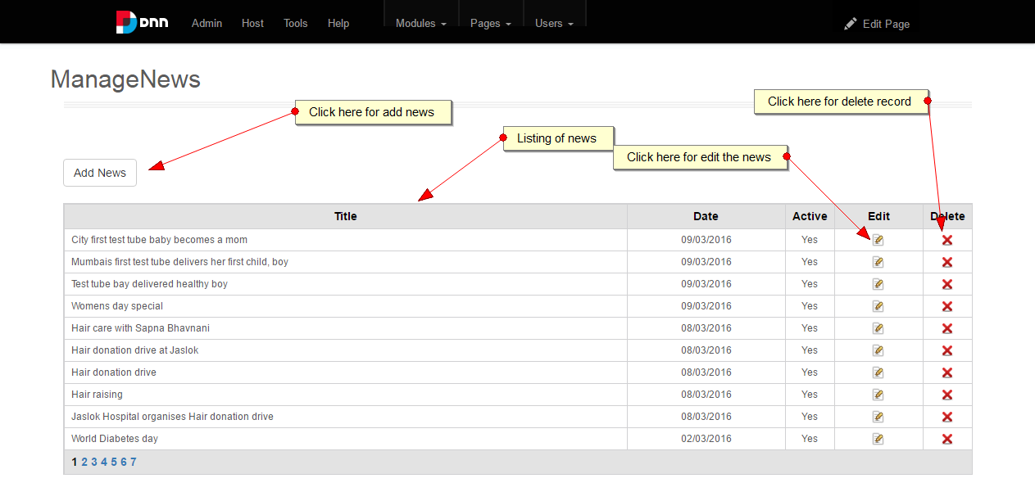

2.

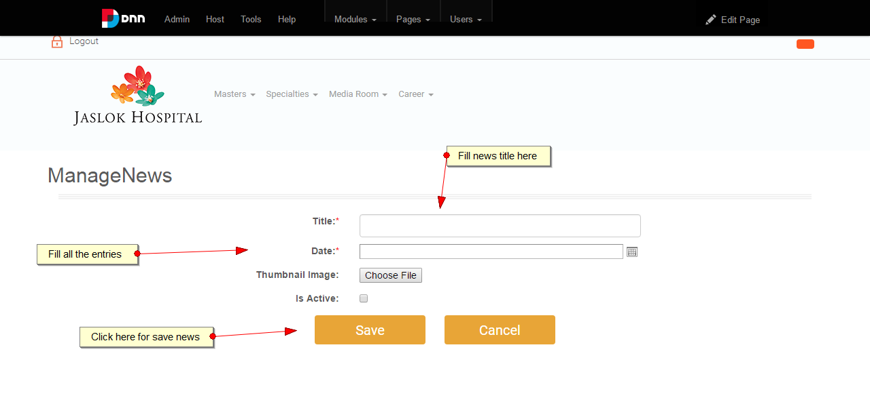

3.

